Name: Aarya Tiwari   
Roll number: 16010421119   
Batch B1  
Experiment 3

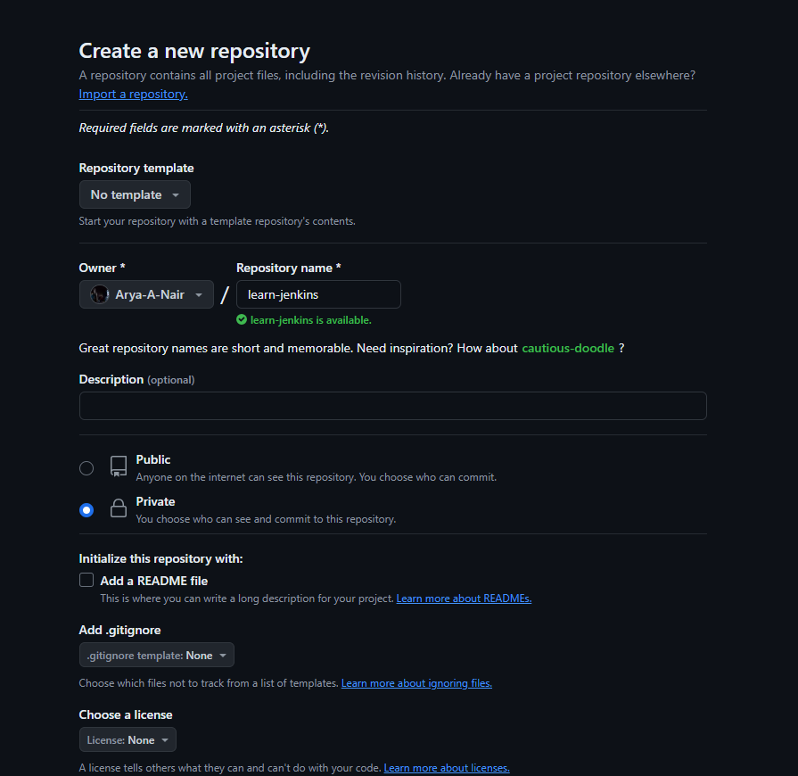

Create a repository for the codebase

\

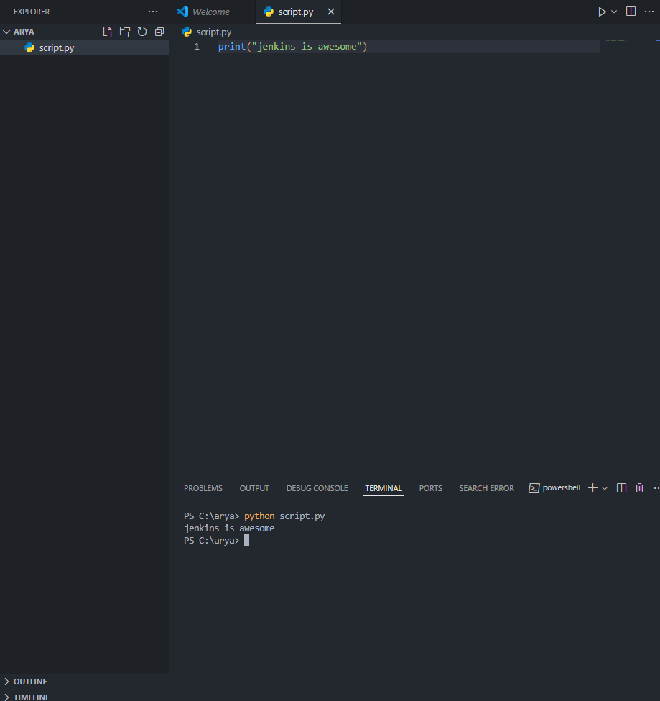

Python script to run

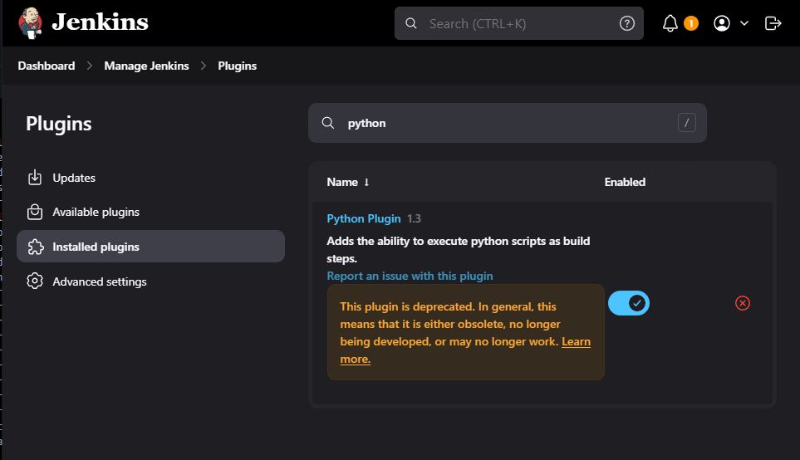

Add python plugin

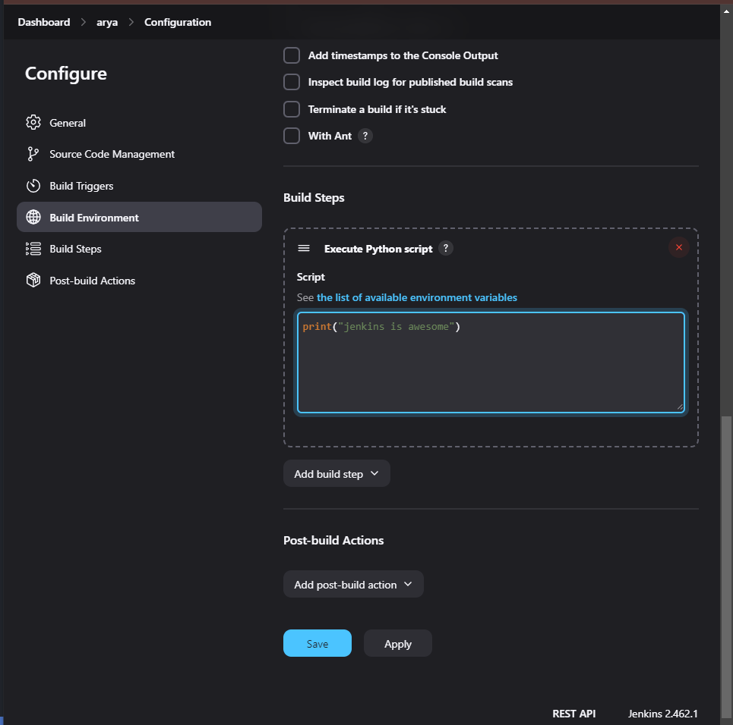

Execute python script in jenkins

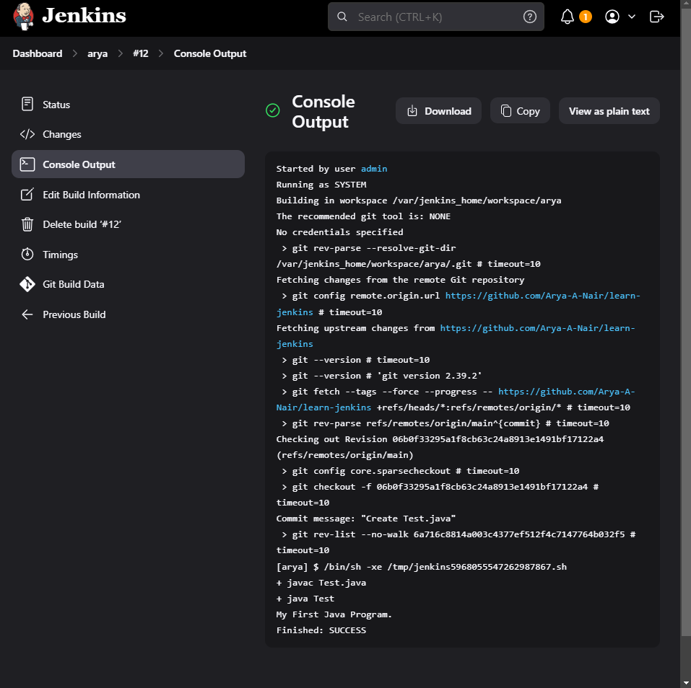

Implement CI pipeline for running the code

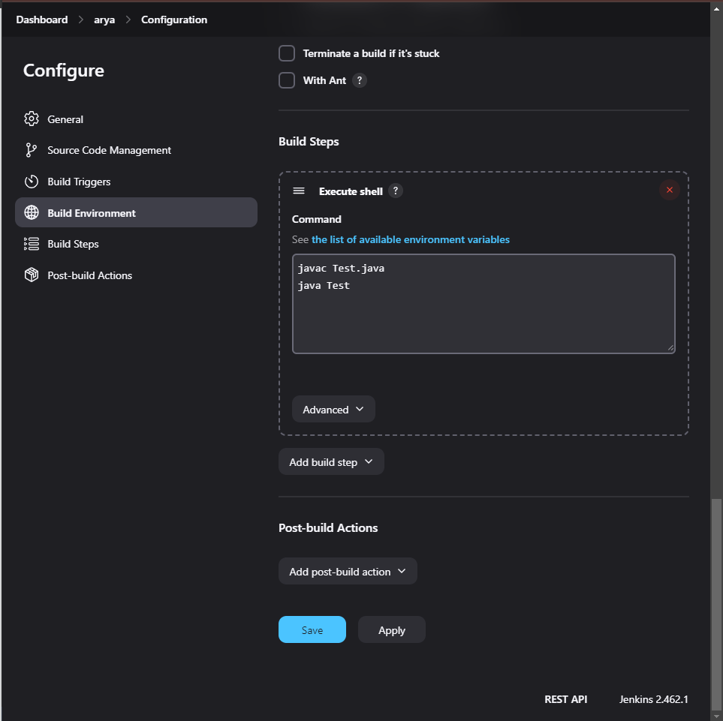

Add java commands to run the java program

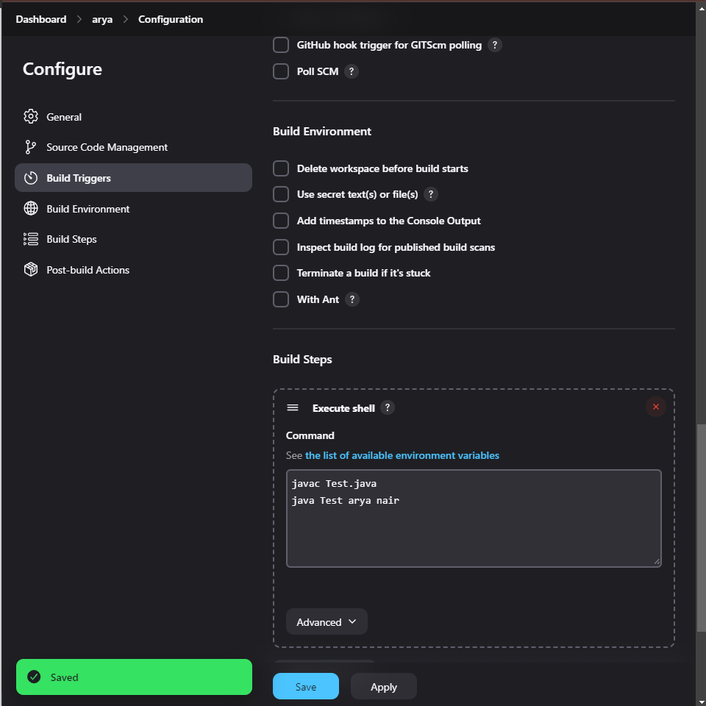

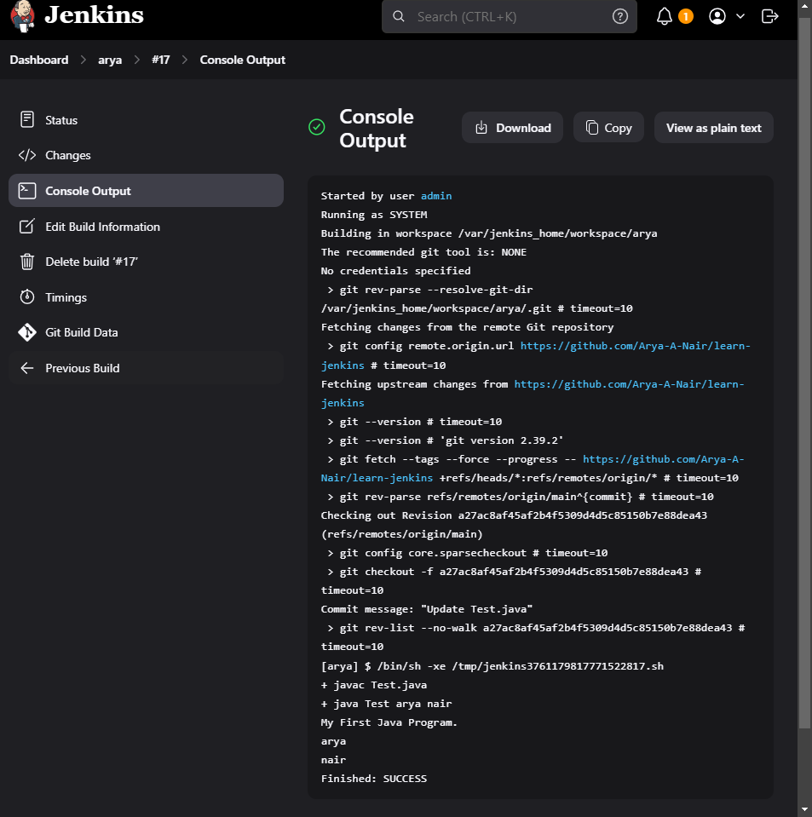

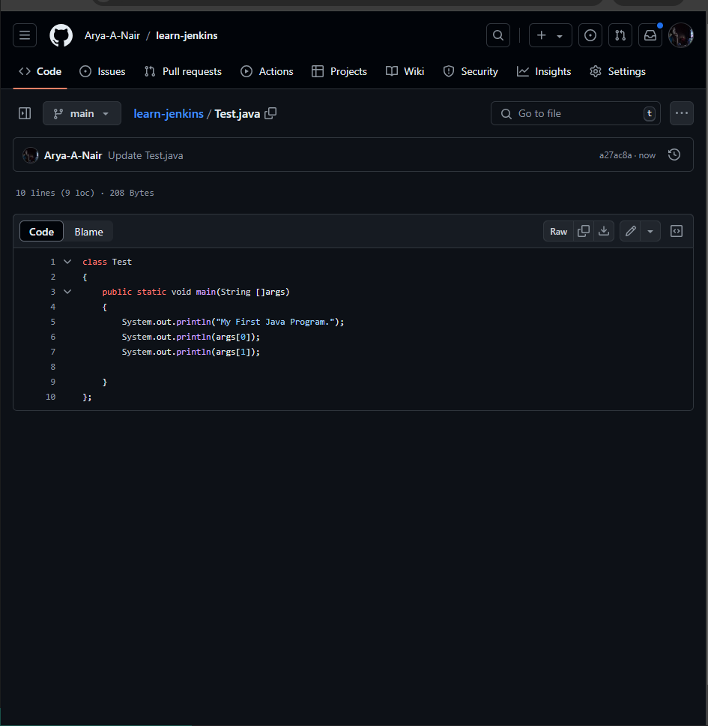

code which is being run in the CI pipeline

Questions:   
1. Explain difference between system configuration and global tool configuration.

In Jenkins, system configuration encompasses global settings that govern the overall behavior of the Jenkins instance, such as security policies and system-wide environment variables. In contrast, global tool configuration focuses on setting up and managing tools like JDK, Maven, or Git, which are used across various Jenkins jobs. While system configuration ensures the general operational integrity of Jenkins, global tool configuration standardizes and centralizes the tools available to all projects, promoting consistency and ease of management.

Outcomes   
CO3 Comprehend the effective code building and testing process

Conclusion   
Run java programs using jenkins